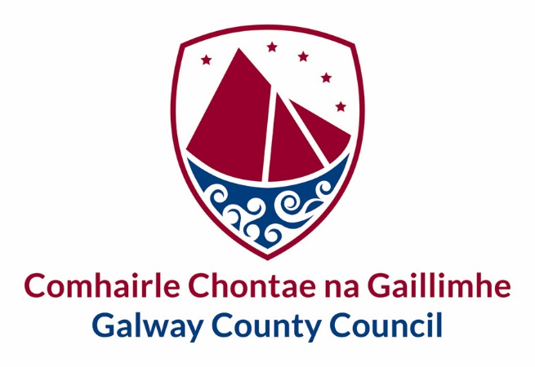

Privacy Notice – [Number Plate Recognition (NPR)]

Document Information

Document Title | Privacy Notice – [Number Plate Recognition (NPR)]
Owner | Galway County Council
Author(s) | Data Protection Officer
Users | Galway County Council Staff and Citizens
Date | 11/12/20
Status | Adopted
Version | 1

Version History
Version | Created/Amended By | Date | Description
1 | Liadhan Keady | 11/12/20 | Privacy Notice [Number Plate Recognition (NPR)]

Galway County Council is the local authority for the County of Galway and in performing its functions, Galway County Council is required to process significant amounts of “Personal Data” within the meaning of the Data Protection Acts 1988 / 2003/2018 (“the Acts”) and the European regulations 2016/679 (GDPR). Galway County Council respects the privacy rights of those whose Personal Data we process and we are conscious of our obligations under the Data Protection Acts.

This Privacy Notice explains how Galway County Council will process Personal Data collected through [Automatic Number Plate Recognition (ANPR)].

What type and how will your Personal Data be collected?
The Automatic Number Plate Recognition (NPR) CCTV deployment is essentially capturing car registration details only and there is no automated matching of data to any database. Please refer to Appendix 7 of Galway County Council’s CCTV Policy which provides an inventory of CCTV camera’s installed by Galway County Council across County Galway and their current operational status.
The purpose of the ANPR deployment is to detect, deter and disrupt illegal activity including anti-social behaviour and illegal dumping and therefore impact significantly on those involved in such activity.
There is no processing of special category data. The NPR data is not cross referenced with NDLS information and is therefore not Automatic in nature.
There is appropriate signage in place confirming that CCTV cameras are operational and includes details of the Data Controller.

What is our lawful bases for processing your Personal Data?
Galway County Council’s lawful basis for processing Personal Data collected from Automatic Number Plate Recognition (ANPR) is as follows:
- Article 6(1)(e) determines that processing is lawful where it is necessary for the performance of a task carried out in the public interest or in the exercise of official authority vested in the controller.
- Law Enforcement Directive:
- Litter Pollution Act, 1997 (as amended)
- Waste Management Act, 1996 (as amended)
- Local Government Act, 2001 Section 66
- Section 38 (3) (c) Garda Síochána Act, 2005

Who will your Personal Data be shared with?
We may share your personal data internally with relevant departments for the purpose of fulfilling the above stated legal basis. The footage will be shared under the legal basis of performing a task carried out in the public interest.
Where we have arrangements to share your personal data, there is a contract, memorandum of understanding or information sharing agreement in place to ensure that the requirements of the Data Protection legislation on handling personal information are met. Where we are required to disclose information by law, for example for safeguarding purposes, we may do so without these arrangements.
We engage with third party processors who handle some, or all, of the above mentioned information on our instruction.
Galway County Council will take steps to ensure any disclosures of personal data are necessary and proportionate, as required by law. Whenever we share your personal information, sharing options will be evaluated to ensure that your data is shared in the most secure manner.
How will we protect your Personal Data?
Any data we collect will be stored confidentially and securely as required by the Galway County Council Privacy Statement, Data Protection Policy & CCTV Policy. Galway County Council is committed to ensuring all accesses to, uses of, and processing of, Galway County Council data is performed in a secure manner.
How long will we hold your Personal Data?
Data recorded on CCTV systems shall be kept for no longer than is considered necessary in accordance with Article 5(e) of the GDPR.
- Normally data recorded on all CCTV systems as included in this policy, will not be retained by Galway County Council beyond a maximum of 30 days.
- Data recorded on CCTV systems may however be retained by Galway County Council beyond a maximum of 30 days in circumstances where the data is required for evidential purposes and/or legal proceedings.
What are your rights?
For further information on how Galway County Council processes Personal Data and your rights, please refer to Galway County Council’s Privacy Statement, Data Protection Policy and CCTV Policy which can be found on our website galway.ie.
OR
You may contact Galway County Council 's Data Protection Officer at 091 509000 or dpo@galwaycoco.ie

Right of Complaint to the Office of the Data Protection Commissioner
If you are not satisfied with the outcome of the response you received from Galway County Council in relation to your request, then you are entitled to make a complaint to the Data Protection Commissioner who may investigate the matter for you.
The Data Protection Commissioner’s website is www.dataprotection.ie or you can contact their Office at:
Lo Call Number: 1890 252 231
E-mail: info@dataprotection.ie
Postal Address: Data Protection Commissioner
Canal House
Station Road
Portarlington,
Co. Laois
R32 AP23

